Republic of Iraq

Ministry of higher Education and scientific research

Kerbala University

College of Science

Chemistry department

Microwave-Assisted Synthesis of 2,3-Disubstituted - 1,3 imidazolidines-4-one Based on 3 -Acetyl coumarin moiety .

By

Rawhya Nather Farman

Enas Deyaa Abdullah

Maryam adil hussain

Supervised by

Sajid Maksad Radhi

1442 B.H 2021 A.C

**بسم الله الرحمن الرحيم**

# ﴿...وَقـل ربِّ زدْنـي عِلْمًا﴾

**صدق الله العظيم**

**)سورة طه/114(**

## Dedication

To the soul which lives with me all times… (My father)

To light my eyes which encourages me all times…

(My mother) with respect.

To crown of my head which was a candle to my path all times… (My brothers ) with respect.

Acknowledgment

Thanks to Allah the one the single for all this blessing during my study and all my life.

I would like to express my sincere thanks and my appreciation to my supervisor M.Sc. Sajid Maksad Radhi

Also my grateful thanks to the staff members of the College of science. My deep grateful thanks are due to the

department chemistry head

Assist.Prof.Dr.Adnan l.M0hammed

Also I would like to give my thanks to all my friends. I am deeply indebted to my family for their support and patience during the years of my study with appreciation.

|  |  |
| --- | --- |
|  | absolute ethanol to produce six imines of **3-(2-hydrazinylacetyl)-2H chromen-2-one**. ,Schiff bases ( 2a-d) treated with 2-aminoacetic acid ( glycine) to produce Imidazolidine derivatives of **3-(2-hydrazinylacetyl)-2H-chromen-2-one**. The chemical structures of the synthesized compounds were confirmed by means of , FT-IR spectra were recorded using Fouriet transform infrared SHIMADZU - FT-IR-8400S infrared spectrophotometer by KBr disc, University of Kerbala.  **Keywords:** Green chemistry; Microwave radiation; 4-Aminoantipyrine ; Imines; Imidazolidines. |
|
|
|
|
|
|
|
|
|
|
|
|
|
|
|
|
|
|
|
|
|
|
|
|
|
|
|
|
|
|
|
|
|
|
|
|
|
|
|
|
|
|
|
|
|
|
|
|
|
|
|
|
|
|
|
|
|
|
|
|
|
|
|
|
|
|
|
|
|
|
|
|
|
|
|
|
|
|
|
|
|
|
|
|
|
|
|
|
|
|
|
|
|
|
|
|
|
|
|
|
|
|
|
|
|
|

**Abstract:** Series of schiff bases( 2a-d) are synthesized by the reaction a various aromatic aldehydes( salicylaldehyde 1a , 3-Hydroxybenzaldehyde 1b , 4-Hydroxy-3methoxybenzaldehyde 1c, 4-aminobenzaldehyde 1d, , respectively) with

3-(2-hydrazinylacetyl)-2H-chromen-2-one (1) using microwave irradiation method in

### 1.1.Schiff Base

A Schiff's base [1] ,(or **azomethine** which refers specifically to secondary aldimines ), named after Hugo Schiff, is a functional group that include a carbon–nitrogen double bond with the nitrogen atom linked to an aryl or alkyl group but not hydrogen. Schiff's bases are of the general formula R1R2C=N–R3, where R3 is a phenyl or alkyl group that draws the Schiff base a fixed imine. Schiff's bases can be innovated from an aliphatic or aromatic amine and a carbonyl compound by nucleophilic addition arranging a hemiaminal , pursued by a dehydration to create an imine [2]. As revelation in diagram (1-1) shows the common structure of Schiff base.

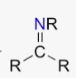

Scheme (1-1) The general structure of Schiff base

### 1.2.Preparation of Schiff bases

Primary amines interact against aldehyde or ketone to shape intensification outputs that are called Schiff bases, as shown in diagram (1-2). Schiff was the first who reported like interaction [3].

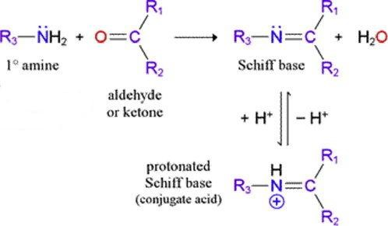

Scheme (1-2) preparation of Schiff bases

#### 1.2.1. Mechanism of imine formation

The mechanism of the intensification reaction of the carbonyl compound and the amine includes two steps, the premier step is the incipient addition of the amine to carbonyl compound forming a carbinolamine follow up by the second step which is dehydration to output the imine compound including the (-C=N-) bond, as shown in diagram (1-3) [4,5].

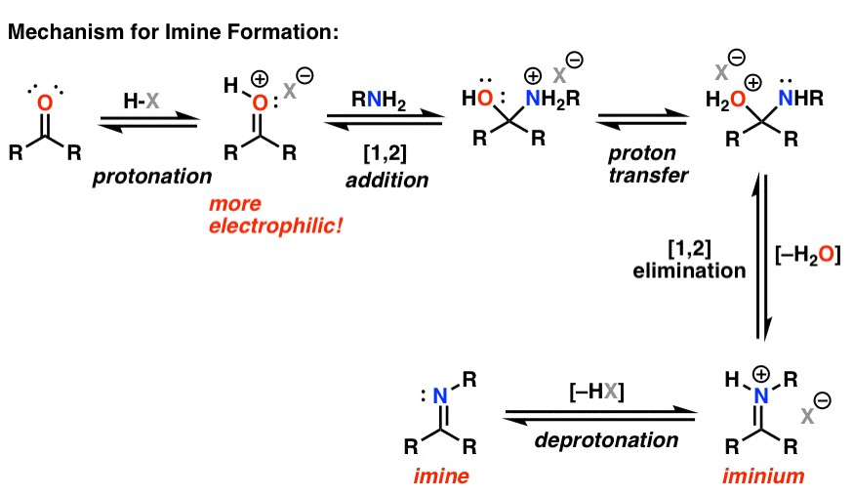

Scheme (1-3): Mechanism of imine formation

### 1.3.Reaction of Schiff bases

Schiff bases subject addition reaction of azomethine, the reagents are put into polarized double bond , thus nucleophilic reagents raid the carbon atom of the azomethine correlation. N-Benzylidenearylamine interacts acid halides such as acetyl chloride [4] and 4-methoxybenzoyl chloride [5] to shape the addition output , as shown in diagram (1-4) .

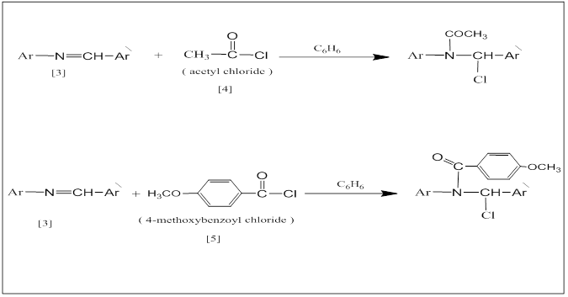

Scheme (1-4) Addition reactions

Grignard reagent [6] was added up to the Schiff bases to grant secondary amines later hydrolysis of the addition outputs, as shown in diagram (1-5) .

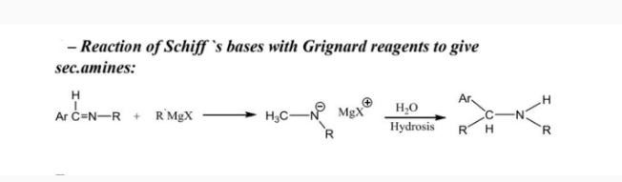

Scheme (1-5) Grignard reagent

#### 1.3.1. Cycloaddition Reaction

For many years, the Diels-Alder interaction was the solely widely helpful example of the so-called cycloaddition interaction. The dimerization of olefins, as well as the addendum of carbenes and nitrenes to unsaturated focuses has expanded the series to involve three-, four-, five- and six membered ring systems.

##### 1.3.1.1. Three-Membered Rings

Dichlorocarbene was added to N-benzylidene aniline to grant the corresponding dichloroaziridine [6] [7] as shown in diagram (1-6).

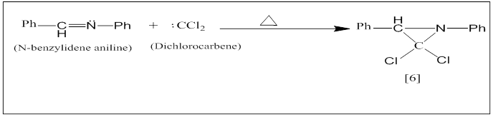

Scheme (1-6) preparation Three-Membered Rings

##### 1.3.1.2. Four-Membered Ring

Patel et al. [8] reported the forming of azetidinone from the interaction of

Schiff bases derivatives with Chloroacetic acid chloride and lesson biological activity of these composite, as shown in diagram (1-7).

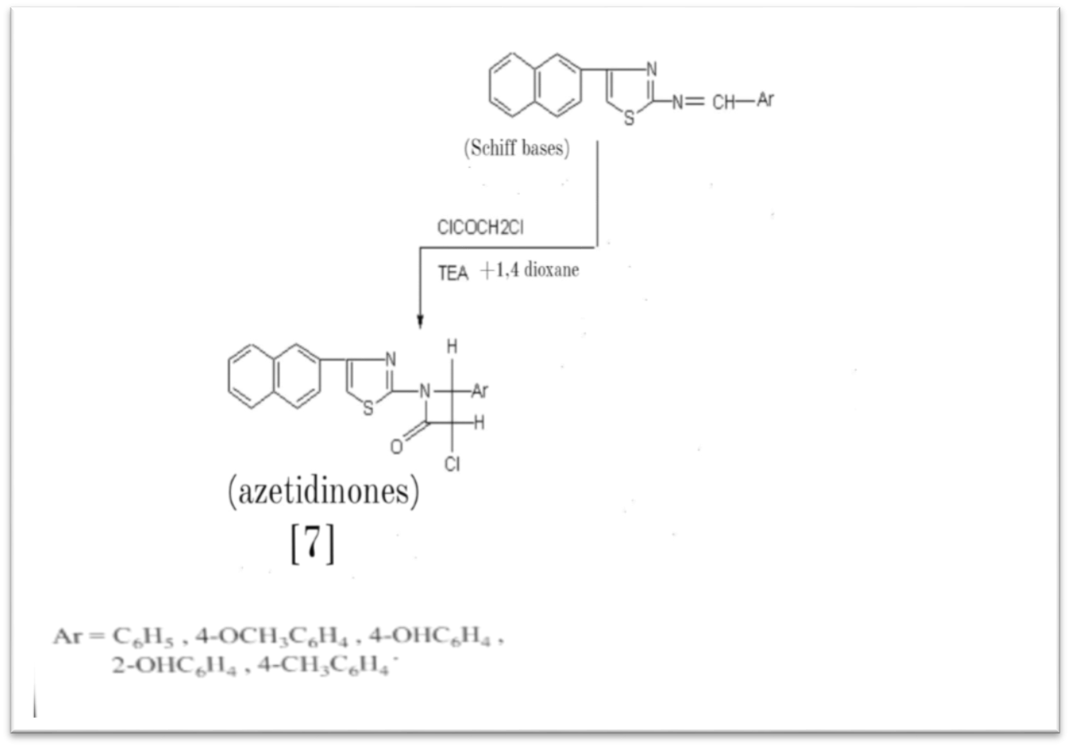

Scheme (1-7) preparation Four-Membered Ring

##### 1.3.1.3. Five-Membered Rings

Ahmed [9] Attended thiazolidine-4-one from the interaction of Schiff bases derivatives [9] with Thioglycolic acid [10] as shown in diagram (1-8).

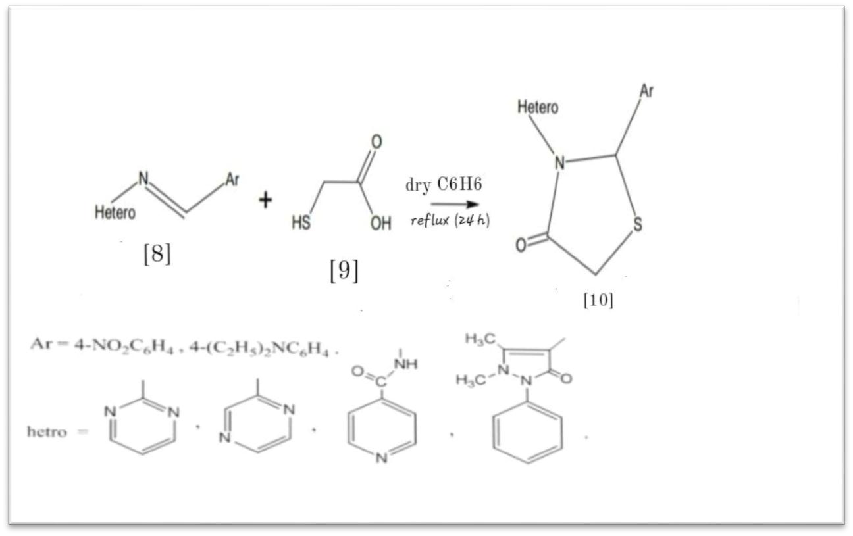

Scheme (1-8) preparation Five-Membered Rings

##### 1.3.1.4. Six-Membered Rings

Mehdi et al. [10] Attended (6-chloro-2,3,5-triphenyl-1,3-oxazine-4-one) [11] from the interaction of (chlorocarbonyl) phenyl ketene [12] with n-benzalaniline, (Schiff base of Benzoic aldehyde) as shown in diagram (1-9).

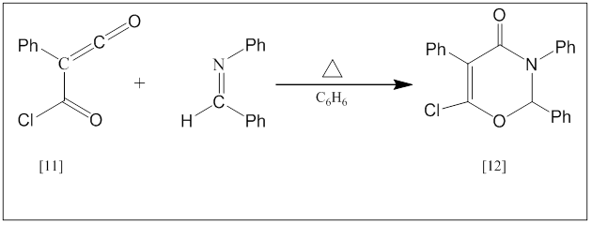

Scheme (1-9) preparation Six-Membered Rings

#### 1.4. Applications of Schiff bases

Schiff bases and its complicated have sundry applications in variation fields epitomize as following :

##### 1.4.1. Analytical application

Many of Schiff bases is find as ligands poly chelating tinted forms complexes with many of metals ions , thence make eclectic and sentient methods to be specified the mineral [ 11 ] .

##### 1.4.2. Biological applications

Schiff bases have biological activity , thus use in Preparation of some drugs like pyridine-4-carbohydrazide, appearance anti phthisis energetic , the amino group appears poisoning in application as Explained in diagram (1-10) :

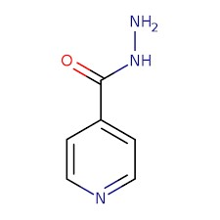

Scheme (1-10) isonicotinyl hydrazide

The Poisoning removed by transformation of the compound to the Schiff bases by concentration with ketones or aldehydes[ 12 - 13 -14 ] . yet, the utilize of some Schiff bases in (optical process) [ 15 ]  and Interactions Included imine group (non-enzymatic transition Interactions) [16,17] and some quickened Interactions by vitamin (B6) [18] and some of Schiff bases have activity counteract cancer

disease [ 19 ] .

###### **1.4.3. Industrial applications**

When some Schiff bases mingle with oxidized factor (molecular oxygen , organic Dioxidane and Phenyl iodide ) by appointed proportions , produce Corresponds effective system use catalytic agent cannot manufacture that solo, e.g. (Col) complex which Schiff base is [(N,N'-Disalicylideneethylenediamine](https://www.ncbi.nlm.nih.gov/pcsubstance/?term=%22N%2CN%27-Disalicylideneethylenediamine%22%5bCompleteSynonym%5d%20AND%2026518%5bStandardizedCID%5d) L,L = N, N ) which utilized as catalytic Factor to oxidize the hydrazones to diazo compound which use in organic production It includes the peptides [20] , oxidation of asymmetrical sulphide to sulphoxide as well through utilized organic hydroxides using quantity of one of Visual Effective compounds Such as vanadium Schiff bases complicated [ 21 ] . Manganese complicated used with Schiff bases catalytic factors in epoxidation of olefins through blending with Phenyl iodide as oxidation factor [ 22 ]. Some of polymerized Schiff bases which Includes furan groups forms high sentient semi conductive [ 23 ] . Nickel Schiff bases complicated are uses color pixie to the estimate thermal impedance when the proportional of the used chelate not raise on 10% of the classification weighing [ 24 ] . as well Schiff bases complicated use as oxidized Factor to the sulphur composites in oil [ 25] .

The mix of Schiff bases ligands used with convey mineral as pixie to the gasoline and polymer [ 26] .

#### 1.5. Imidazolidines compounds

1,3-Diazacyclopentane is a hetero cyclic 5-membered compound

(CH2)2(NH)2CH2. The Origin imidazolidine is light thoughtful, but concerning compounds replaceable on one or both nitrogen center on are most popular. as a rule, they are colourless, polar, essential compounds.

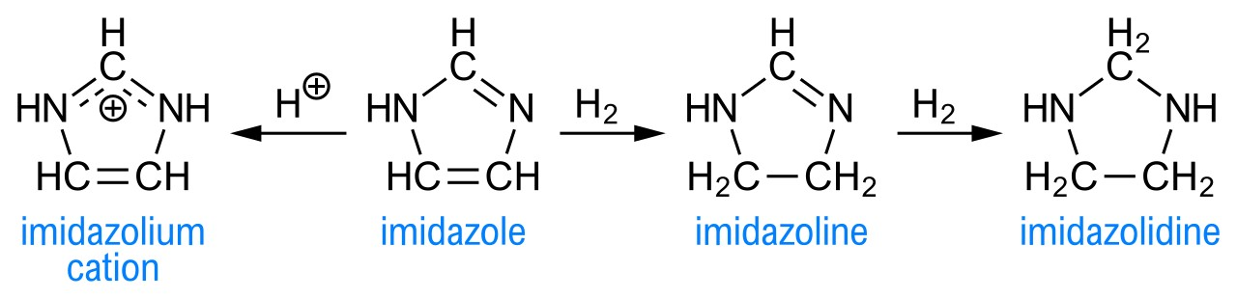

##### 1.5.1 .Preparation of Imidazolidines

1,3-Diazacyclopentane are conventional prepared by Intensification reaction of 1,2-diamines and aldehydes. most popular, one or both nitrogen center on is replaceable with an alkyl or benzyl (Bn) group [27] , The first unsubstantiated imidazolidine Installation was determination in 1952. [28]

(CH2NBn)2 + Ph-CHO → (CH2NBn)2C(H)Ph + H2O

#### 1.6. Important of Imidazolidines

Imidazolidines (saturated imidazoles), also recognized as tetrahydroimidazoles are biologically active Nitrogen competing heterocyclic moiety which has been reported to displayed a wide array of important bioactivities [29] .Imidazolidinesdione (hydantoins) and their derivatives are good recognized for their medicinal and many significant non-medicinal applications [30] . The detection of imidazolidine-dione and successfully evolving version hydantoins-based drugs for the therapy of bump [31]. Imidazolidinedione derivatives are reported to display the inclusive ambit of biological activities like as anti-inflammatory [32] analgesic deputies [33], antibacterial [34], antifungal drugs [35], antimicrobial [36] , anti-depressant drugs are widely employed [37],commonly employed in the therapy of bump[38] anti-arrhythmic[39 ].

#### 1.7. Aim of the study

This work goals to create modern Imidazolidines derivatives and characterizing of topic .

##### 2.1. Materials

|  |  |  |  |  |
| --- | --- | --- | --- | --- |
| **Chemicals** | **M.F.** | **M.Wt**  **g/mole** | **Purity**  **%** | **Supplied**  **form** |
| **2-Oxo-2H-chromene-3-carbohydrazide** | C10H8N2O3 | 204.18 | 98 | BDH |
| Salicylaldehyde | C7H6O2 | 122.12 | 99 | GCC |
| 3-Hydroxy benzaldehyde | C7H6O2 | 122.12 | 99 | BDH |
| 4-Hydroxy-3-Methoxybenzaldehyde | C8H8O3 | 152.15 | 98 | Merck |
| 4-Aminobenzaldehyde | C7H7NO | 140 .57 | 99 | Merck |
| Glycine | C2H5NO2 | 75.07 | 99 | BDH |
| Tetrahydrofuran | C4H8O | 72.107 | 99 | GCC |
| Ethanol Absolute | C2H6O | 46.069 | 99 | BDH |
| Diethyl ether | C4H10O | 74.123 | 99 | BDH |

**Table (2-1) shows the utilized chemicals in the experimental part .**

###### 2.2 . Instrumentation

1. Thin layer chromatography (TLC) WAS Performed on aluminum plates and coated with 0.25mm layer of silica gel 60, F254, Compounds were detected by iodine vapor.
2. Melting points were recorded using status melting point apparatus, UK
3. FT-IR spectra were recorded using Fouriet transform infrared SHIMADZU - FT-IR-8400S infrared spectrophotometer by KBr disc, University of Kerbala.

###### **2.3. Synthesis methods**

**(2.3.1)General procedure** **to prepare of imine compounds 1a-d**.

All reactions were carried out on Domestic microwave oven in crucible

,the reactions contained the **2-Oxo-2H-chromene-3-carbohydrazide**

( 0.5g 0.044mol) was dissolved in absolute ethanol ( 1ml ) and, then equimolar amount (0.044mol) of Aromatic aldehydes **(** **Salicylaldehyde** **1a ,**

**3-Hydroxybenzaldehyde 2b**, **4-Hydroxy-3-Methoxybenzaldehyde 3c**

**,** **4-Aminobenzaldehyde 4d )** were added respectively) in the crucible which was put in the middle of a Domestic microwave oven and then heated **(325 W) for (3-10) minutes** , **TLC (n-Hexane: Chloroform: EtOAc ) (3: 2 : 1)** fixed that the reaction has been accomplished. The products were washed with diethyl ether and recrystallized from absolute ethanol.

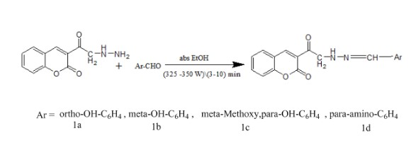

**Scheme (2-1): Synthesis of imines.**

Table (2-2) shows the structures ,chemical formula , molecular weights , melting points and yield % of synthesized compounds(1a-d) .

|  |  |  |  |  |  |  |
| --- | --- | --- | --- | --- | --- | --- |
| **Comp No.** | **Structural formula** | **Name** | **Chemical Formula** | **M.Wt g/mol** | **Mp. OC** | **Yield**  **%** |
| **1a** |  | N'-(2hydroxybenzylid ene)-2-oxo-2Hchromene-3carbohydrazide | C17H12N2O4 | 307.35 | 185 | 89 |
| **1b** |  | N'-(3hydroxybenzylid ene)-2-oxo-2Hchromene-3carbohydrazide | C17H12N2O4 | 307.35 | 179 | 86 |
| **1c** |  | N'-(4-hydroxy-3methoxybenzylid ene)-2-oxo-2Hchromene-3carbohydrazide | C18H14N2O5 | 338.09 | 225 | 75 |
| **1d** |  | N'-(4aminobenzyliden e)-2-oxo-2Hchromene-3carbohydrazide | C17H13N3O3 | 307.30 | 175 | 89 |

**Table (2-2) The Physical properties of compounds(1a-d) .**

**(2.3.2.) General procedure** **to** **prepare of imidazolidines (2a-d)**

A mixture of equimolar amounts of imine derivatives **1a-d** (1 mmol) and glycine (0.075 g, 1 mmol) was heated **(550-600W) in microwave** oven under solvent less conditions for **( 25- 30 ) min** , **TLC (n Hexane: Chloroform: EtOAc ) (3: 2 : 1)** indicated that the reactions have been completed. The products were washed with diethyl ether and recrystallized from absolute ethanol.

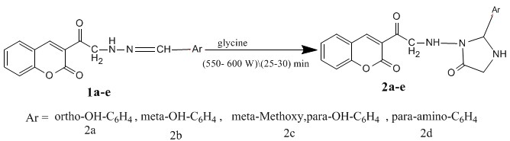

**Scheme (2-2) Synthesis of imidazolidines(2a-d).**

Table (2-3) shows the structures , chemical formula , molecular weights , melting points and yield % of synthesized compounds ,(2a-d) .

|  |  |  |  |  |  |  |
| --- | --- | --- | --- | --- | --- | --- |
| **Comp No.** | **Structural formula** | **Name** | **Chemical Formula** | **M.Wt g/mol** | **Mp.OC** | **Yield**  **%** |
| **2a** |  | N-(2-(2hydroxyphenyl)-5oxoimidazolidin-1-yl)2-oxo-2H-chromene-3carboxamide | C19H15N3O5 | 365.34 | 212 | 88 |
| **2b** |  | N-(2-(3hydroxyphenyl)-5oxoimidazolidin-1-yl)2-oxo-2H-chromene-3carboxamide | C19H15N3O5 | 365.34 | 201 | 85 |
| **2c** |  | N-(2-(4-hydroxy-3methoxyphenyl)-5oxoimidazolidin-1-yl)2-oxo-2H-chromene-3carboxamide | C20H17N3O6 | 395.37 | 205 | 76 |
| **2d** |  | N-(2-(4-aminophenyl)5-oxoimidazolidin-1yl)-2-oxo-2Hchromene-3carboxamide | C19H16N4O4 | 364.35 | 172 | 78 |

**Table (2-3) The Physical properties of compounds (2a-d) .**

**3.1**

**. Synthesis and identification of Schiff base derivatives(**

**1**

**a**

**-**

**d)**

In the First step the treatment of the **3-(2-hydrazinylacetyl)-2H-chromen-2-one** with substituted aromatic aldehydes ( Salicylaldehyde **,** 3-Hydroxy benzaldehyde , 3-Methoxy- 4-hydroxybenzaldehyde **,** 4-Amino benzaldehyde ) , in suitable solvent (1ml )absolute ethanol afforded the corresponding products **(1a-d)** respectively, as show in scheme (3-1) .

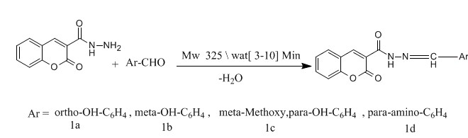

Scheme (3-1)

### 3.2- Synthesis and identification of imidazolidine derivatives( 2a-d)

In the second step the reaction of **(1a-d)** respectively with glycine gave the imidazolidine derivatives corresponding **(2a-d)**, respectively, as show in scheme (3-2) .



#### Scheme (3-2)

All the synthesized compounds [**(1a-d) (2a-d)** ] were characterized by melting points and FT.IR spectra. In the compound **3-(2-hydrazinylacetyl)-2Hchromen-2-one** IR (cm-1): at 3477.77 and 3412.19 cm−1 (ν sym and asym NHNH2 gp , 3084-3057 (ν C-H, benzene), 2928 (ν C-H, aliphatic), 1724.42 (ν C=O, lactone ), 1685.84 (ν C=O ketone), 1606.76 (ν C=C, in coumarin) .

The FTIR spectra of these compounds Figures (3-1) –(3-10)showed good evidence that the condensation reactions happened successfully by disappearing the sharp bands at 3477.77 and 3412.19 cm**−1** (ν sym and asym NH-NH2 gp in **3-(2-hydrazinylacetyl)-2H-chromen-2-one** also the appearance of sharp bands at (1604-1612 ) cm**-1** which due to the υ (C=N) in the imine compounds **(1a-d) .**

In the subsequent stride , the compounds **(1a-d)** have been blended to react with glycine using microwave irradiation to produce imidazolidine derivatives of **(2a-d) ,** in good yields (schedule II). The chemical structure of the objective compounds created have been conclude from IR spectrum of imidazolidine derivatives (2a-e) **,** whichshowed weak absorption bands at (3414.12, 3412.19, 3444.98 , 3350.46 ) cm**-**1 respectively corresponding to ( ν N-H, imidazolidines ) also the disappearance of sharp bands at (1604-1612 ) cm**-1** which due to the υ (C=N) in the imine compounds **(1a-d) .** All bands were listed in table (2-4).

|  |  |  |  |  |  |
| --- | --- | --- | --- | --- | --- |
| **Comp. No** | **υ(C-H) cm-1 aromatic** | **υ (C-H) cm-1**  **aliphatic** | **υ(C=N)** | **ʋ(C=C) cm-1 aromatic ring** | **ʋ (-N-H) cm-1** |
| **1a** | 3064.99 | 2947.33 | 1610.61 | 1558.54 |  |
| **1b** | 3032.20 | 2929.97 | 1610.61 | 1558.54 |  |
| **1c** | 3032.20 | 2929.97 | 1612.54 | 1558.54 |  |
| **1d** | 3063.06 | 2931.90 | 1604.83 | 1558.54 |  |
| **2a** | 3064.99 | 2947.33 |  | 1543.10 | 3414.12 |
| **2b** | 3061.13 | 2926.11 |  | 1545.03 | 3412.19 |
| **2c** | 3032.20 | 2920.32 |  | 1585.54 | 3444.98 |
| **2d** | 3047.63 | 2962.11 |  | 1595.18 | 3350.46 |

Table (2-4) , F.T.I.R Characteristic bands and their location of the compounds .

|  |  |  |  |  |  |  |  |  |
| --- | --- | --- | --- | --- | --- | --- | --- | --- |
| **Comp** | **Physical state** | **Chemical Formula** | **MWt** | **Yield(%)** | **Rf\developer** | **Mp(oC)** | **T\min)** | **MW \ wat** |
| **1a** | **Yellow solid** | **C17H12N2O4** | **307.35** | **89** | **0.69 \ (n Hexane: Chloroform: EtOAc ) (3: 2 : 1)** | **185** | **3** | **325** |
| **1b** | **Brown solid** | **C17H12N2O4** | **307.35** | **86** | **0.68 \ n Hexane: Chloroform: EtOAc ) (3: 2 : 1)** | **179** | **5** | **325** |
| **1c** | **Orange**  **solid** | **C18H14N2O5** | **351.40** | **75** | **0.72 \ (n Hexane: Chloroform: EtOAc ) (3: 2 : 1)** | **225** | **7** | **325** |
| **1d** | **Yellow solid** | **C17H13N3O3** | **325.79** | **89** | **0.76 \ (n Hexane: Chloroform: EtOAc ) (3: 2 : 1)** | **175** | **3** | **325** |
| **2a** | **Yellow solid** | **C19H15N3O5** | **364.40** | **88** | **0.69 \ (n Hexane: Chloroform: EtOAc ) (3: 2 : 1)** | **212** | **26** | **550** |
| **2b** | **Brown solid** | **C19H15N3O5** | **364.40** | **85** | **0.71 \ ( n Hexane: Chloroform: EtOAc ) (3: 2 : 1)** | **201** | **27** | **550** |
| **2c** | **Brown solid** | **C20H17N3O6** | **408.45** | **76** | **0.75 \ (n Hexane: Chloroform: EtOAc ) (3: 2 : 1)** | **205** | **25** | **560** |
| **2d** | **Orange**  **solid** | **C19H16N4O4** | **382.84** | **78** | **0.68 \ (n Hexane: Chloroform: EtOAc ) (3: 2 : 1)** | **172** | **28** | **550** |

Table (2-5) Some Physical Properties Of The Intended Compounds .

### 4. Conclusions

In newfangled years, specific awareness is driven to chemical energy provide economical and environmentally friendly synthesis. In this regard, great importance to search for new ways to activate chemical processes by a chemical reaction under microwave irradiation.

1-The advantages such synthesis include a significant (up to thousands of times) increase in the reaction rate as compared with conventional methods of heating in order to reduce the process time of a few hours or days up to several minutes, 2-Increase the purity and yield of the reaction products microwave activation reagent

1. Can also reduce the amount of solvent or eliminate their use, which corresponds to the concept of "green chemistry " .
2. Imidazolidines and their derivatives are a class of compounds with literature evident pharmacological importance and applications. Therapeutic spectrum is also wide and less explored , therefore, a scientific approach is required to establish the structure activity relations of these biologically and medicinally applicable molecules. Concisely, imidazolidines are among the molecules which have the therapeutic potential for the treatment of various human diseases .

**Scheme (3-3)** **) F.T.I.R spectrum of 2-Oxo-2H-chromene-3-carbohydrazide .**

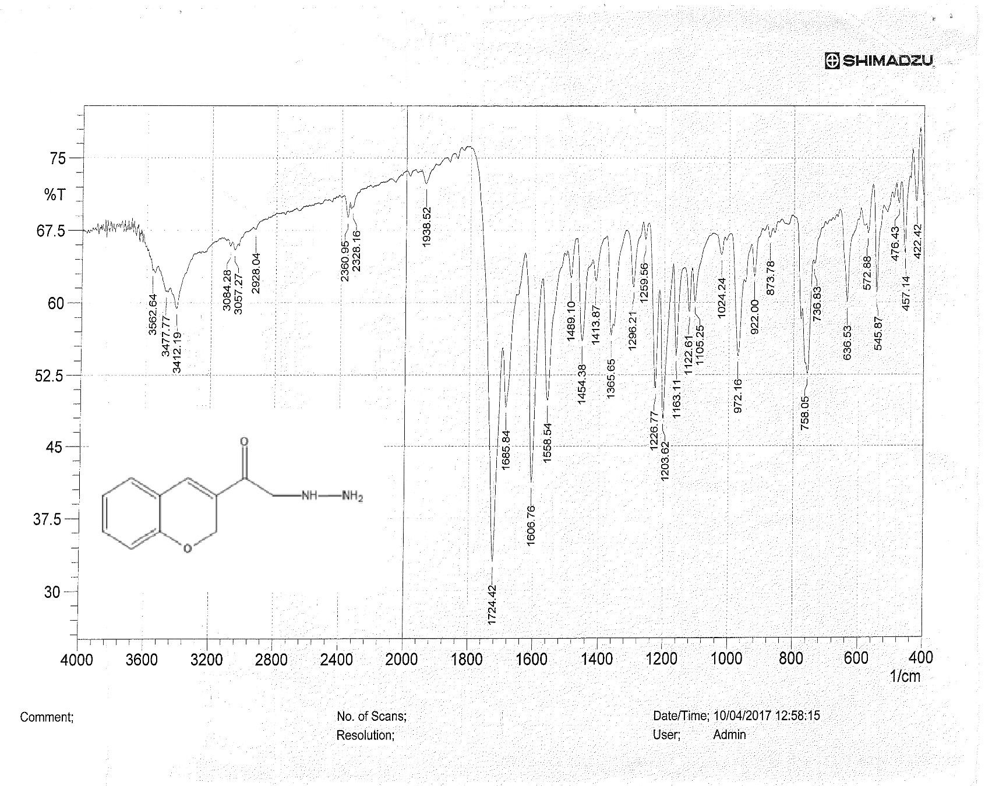

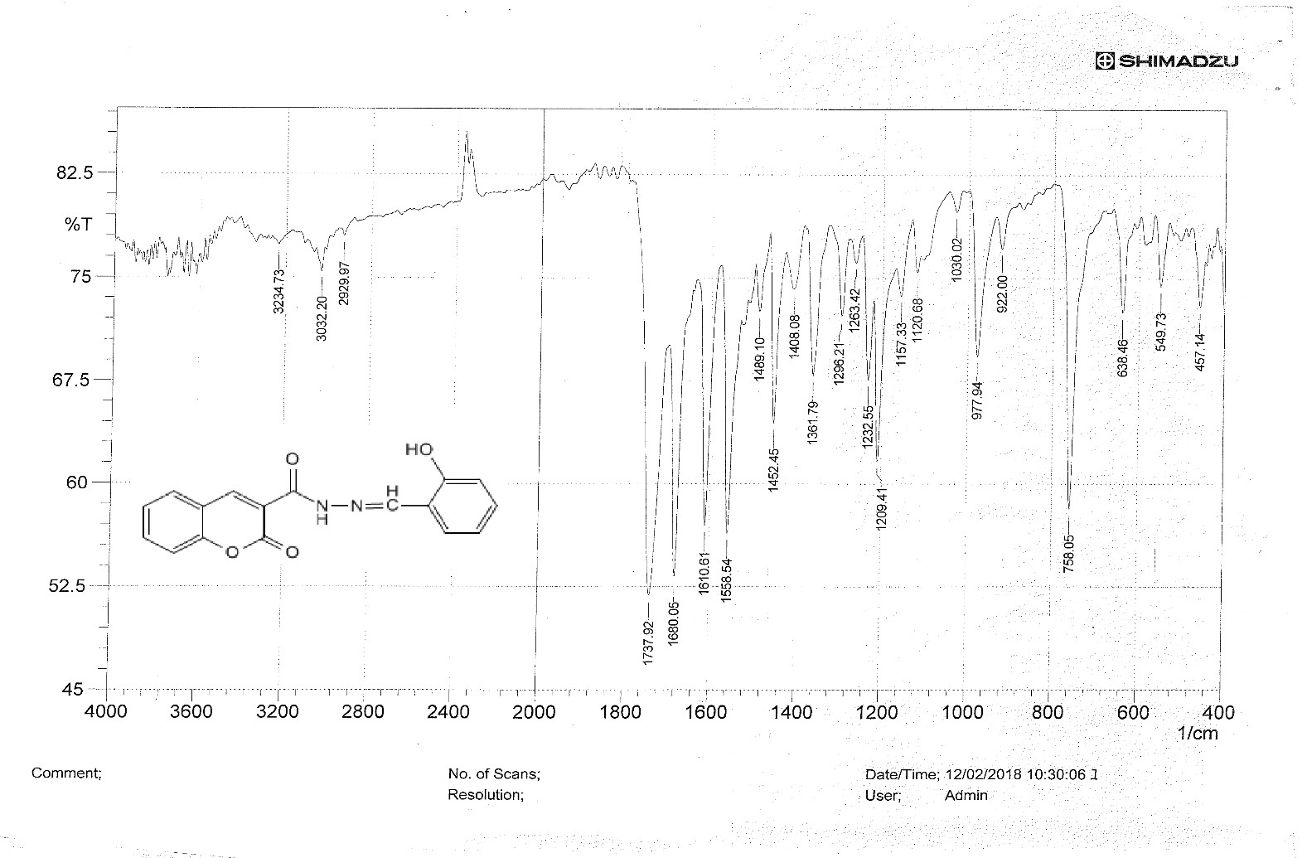**Scheme (3-4) F.T.I.R spectrum of compound 1a .**

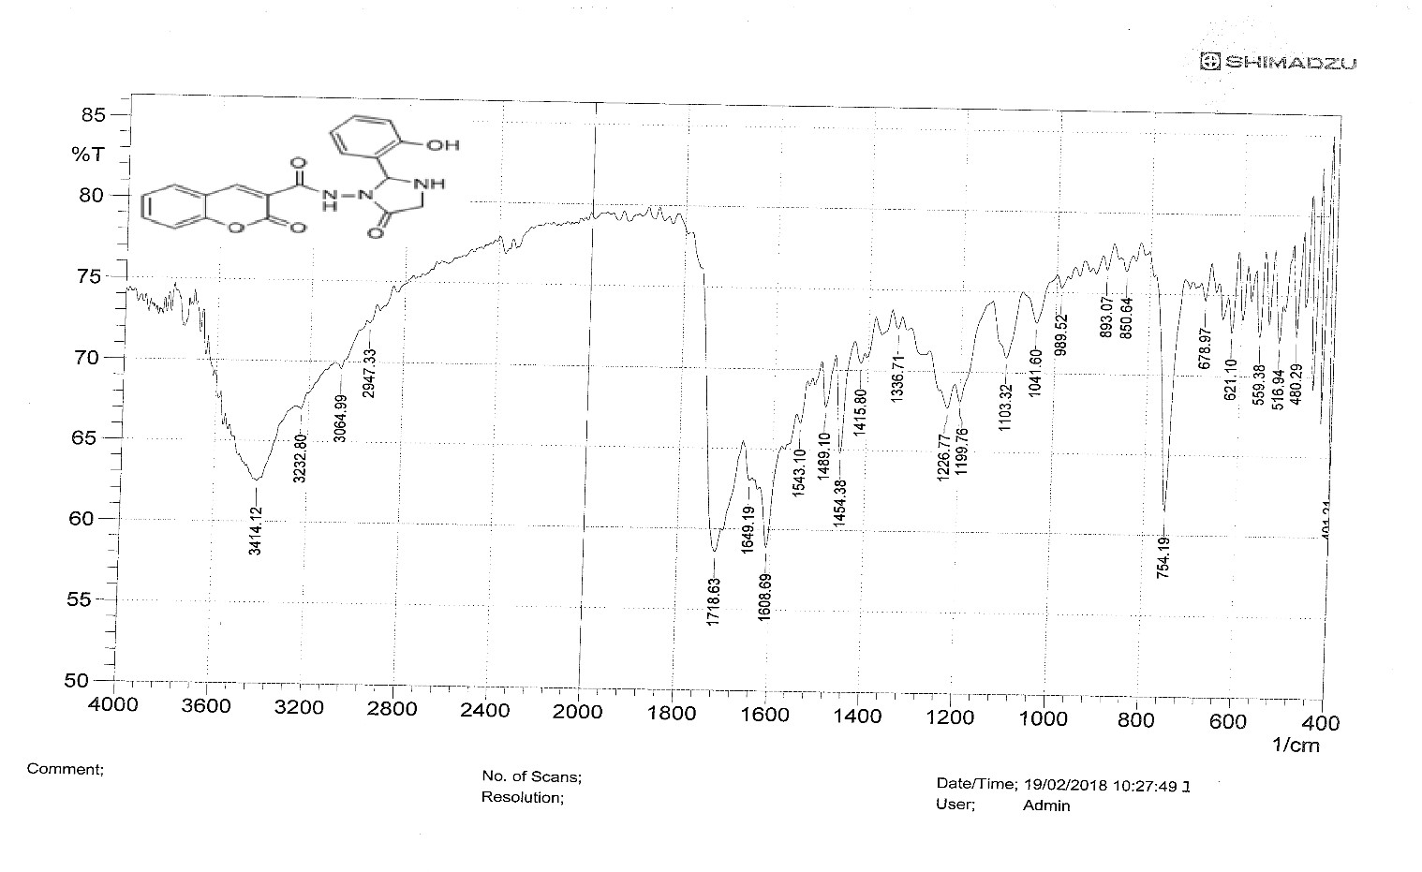

**Scheme (3-5) F.T.I.R spectrum of compound 2a .**

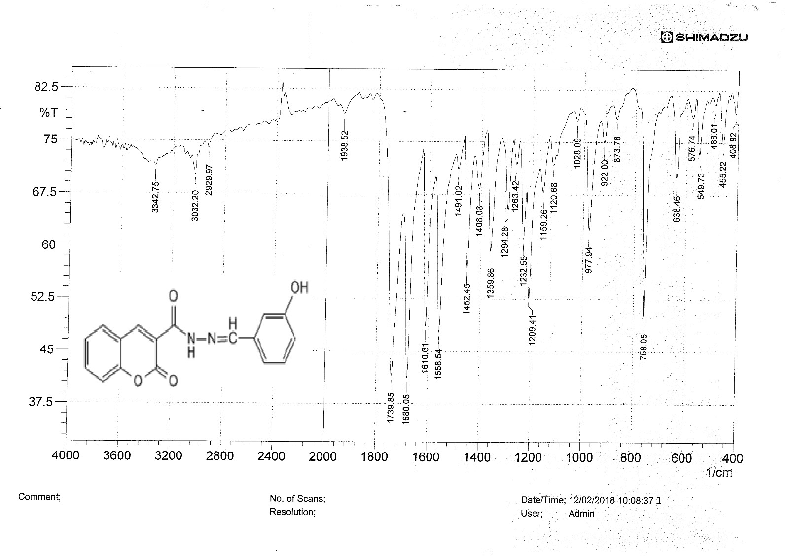**Scheme (3-6) F.T.I.R spectrum of compound 1b**

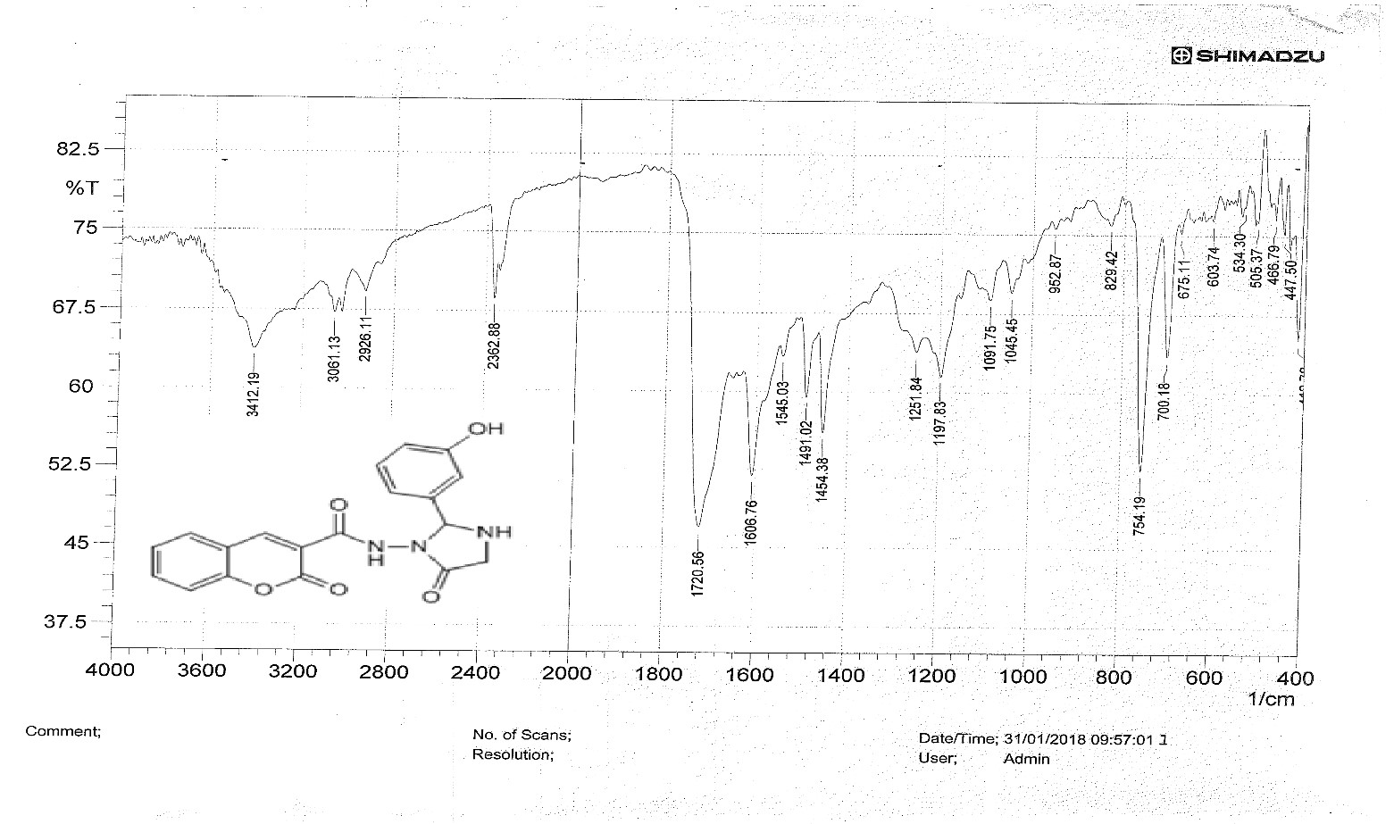

**Scheme (3-7) F.T.I.R spectrum of compound 2b .**

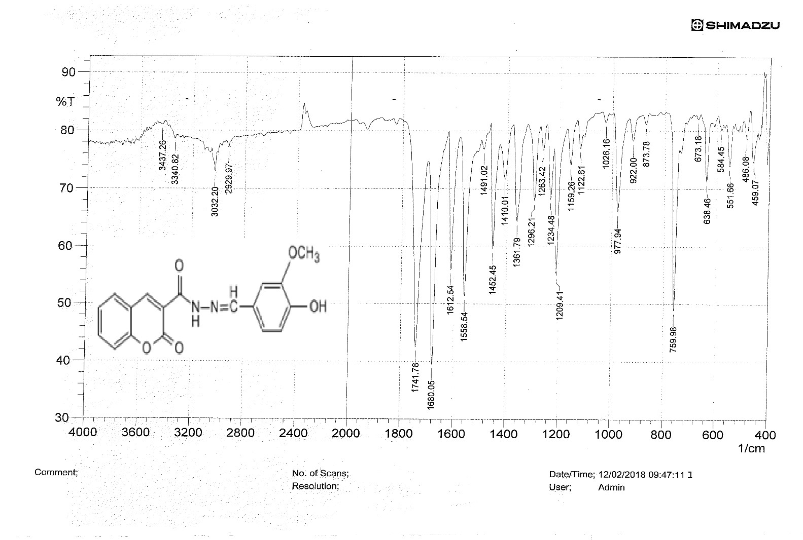**Scheme ( 3-8 ) F.T.I.R spectrum of compound 1c .**

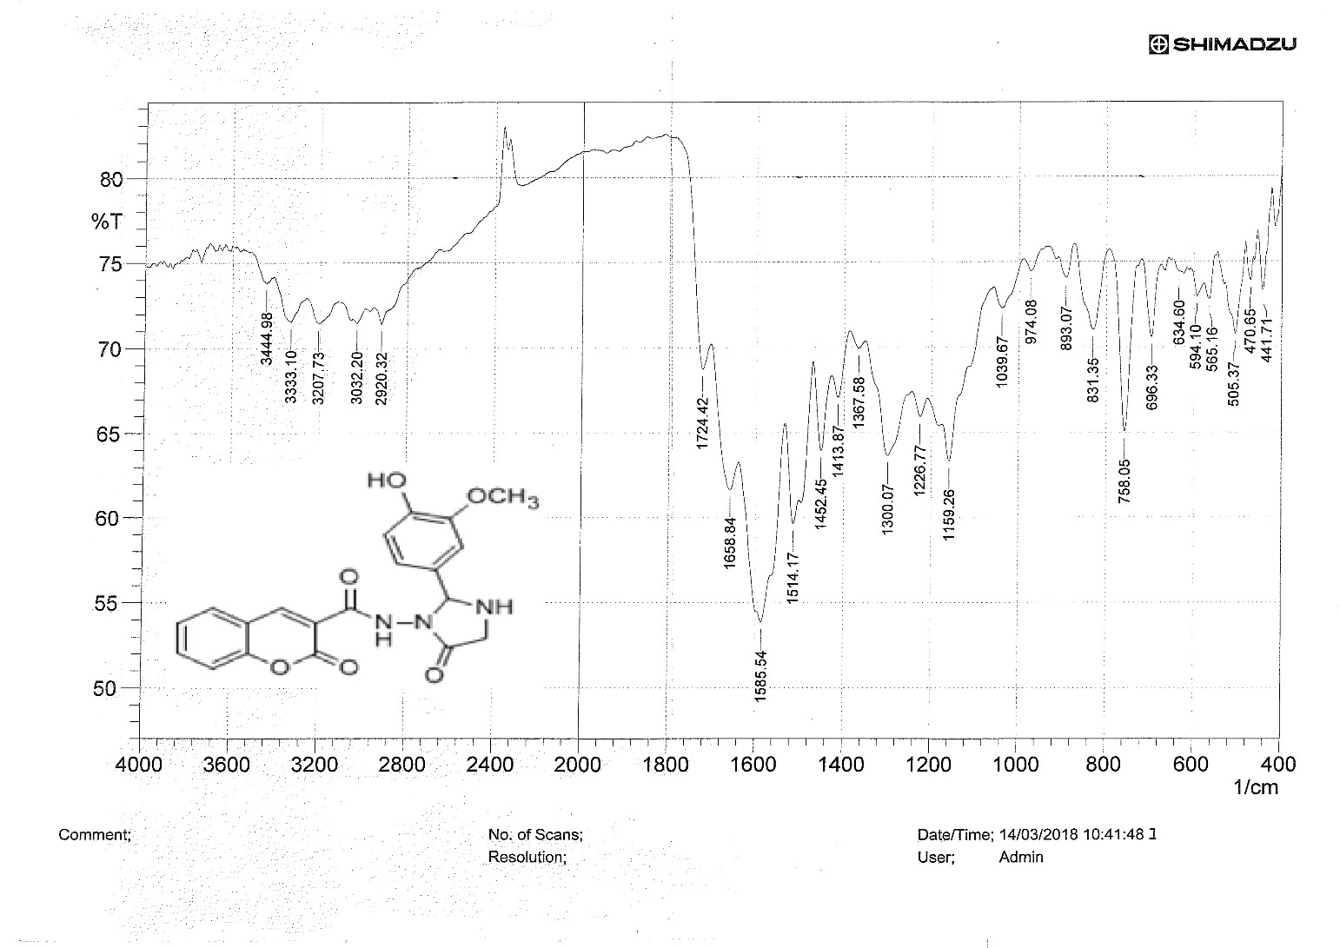

**Scheme ( 3-9 ) F.T.I.R spectrum of compound 2c .**

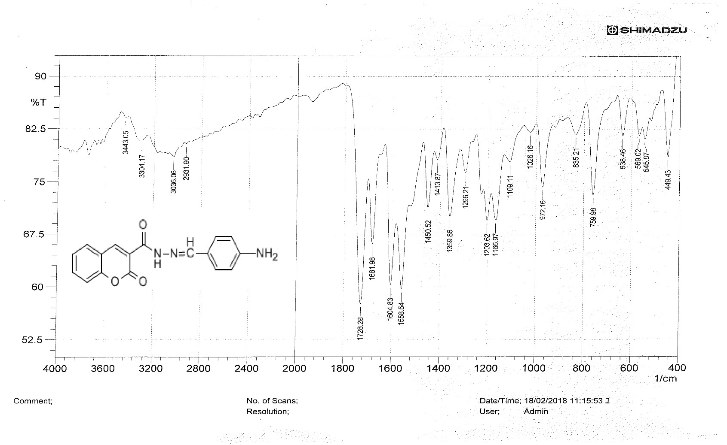**Scheme ( 3-10 ) F.T.I.R spectrum of compound 1d .**

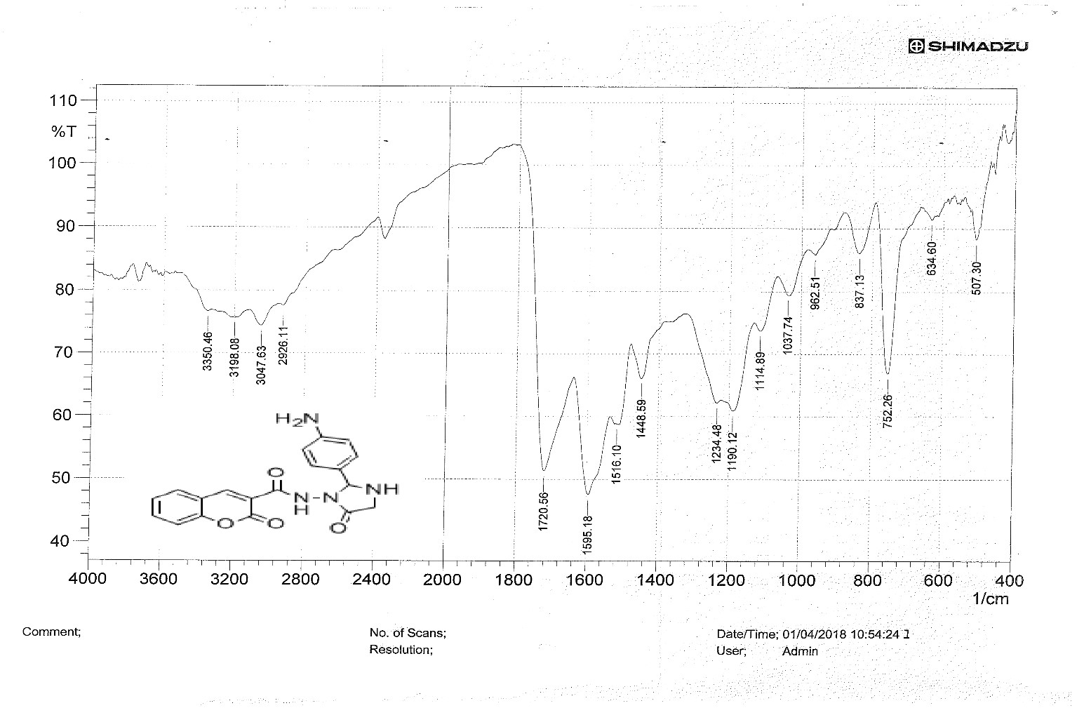

**Scheme ( 3-11 ) F.T.I.R spectrum of compound 2d .**